Semiconductor Fabrication Course Tutorial
2011
Mathematical Interpretation Of The Consumption Of Silicon During The Oxidation Process

During the thermal oxidation process the silicon is consumed to provide the Si in the SiO2 i.e. as the oxide gets thicker the silicon wafer gets thinner. The amount of silicon consumed can be quite easily calculated in the following way.

It takes 1 mole of silicon to form 1 mole of silicon dioxide.

Molecular wt of Si 28.09 g/mole
Volume of 1 mole of Si = ---------------------------- = -------
Density of Si 2.33 g/cm3

= 12.06 cm3/mole

Molecular wt of SiO2 60.08 g/mole
Volume of 1 mole of SiO2 = --------------------------- = ----------
Density of SiO2 2.21 g/cm3

= 27.18 cm3/mole

Volume of 1 mole Si = Thickness of Si x A
----------------------------------- -----------------------------
Volume of 1 mole of SiO2 Thickness of SiO2 x A

Thickness of Si= 12.06
----------------------------------- --------
Thickness of SiO2 27.18

= 0.44
Thickness of Si = 0.44 (Thickness of SiO2)

0.44 µm of silicon is consumed if 1µm of silicon dioxide is grown.

The Thermal Oxidation Model Equation (Grove Model)

Ficks Law States : The particle flow per unit area J (flux) is directly
proportional to the concentration gradient.

1. 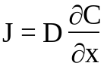

D = diffusion coefficient
N or C = particle concentration

Co is the concentration at the oxide surface this is proportional to the partial pressure of the oxidising species.

At 1000oC for O2 this is 5.2 x 1016/cm3
for H2O this is 3 x 1019/cm3
which explains the much faster oxidation in a wet oxide environment.

6. 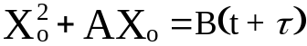

where 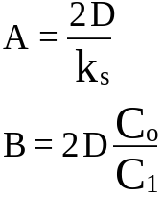

at the boundary condition t = 0 Xo = do

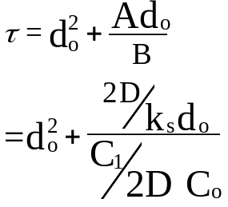

τ  represents a time coordinate shift to take account of any initial oxide thickness before the oxidation takes place (a native oxide or an oxide from a previous oxidation).

7 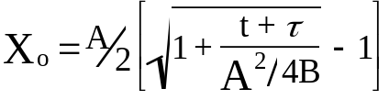

X₀ Is the oxidation thickness grown for an oxidation at time t where A & B are temperature dependant.

For very short times i.e. (t + τ) << A²/4B

This equation simplifies or is approximated by :-

Xo = B/A (t + τ)

This describes the linear growth region

B/A = Linear Rate Constant

For very long times (t + τ) >> A2/4B or t >> 

The equation is approximated by : -

Xo =√Bt This describes the parabolic region.

B = Parabolic rate constant

Thermal Oxidation Understanding

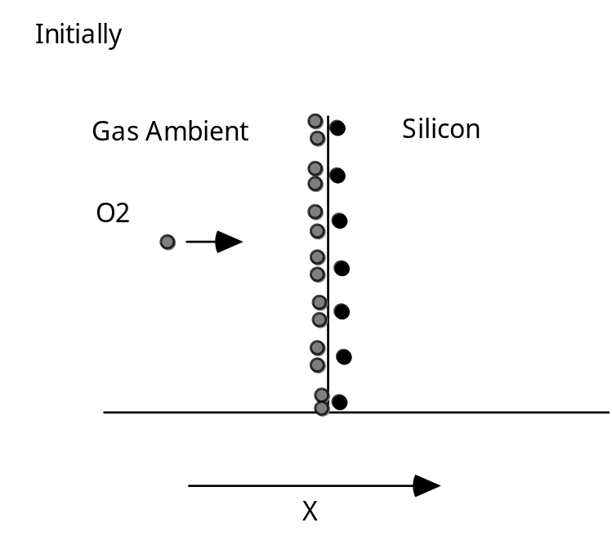

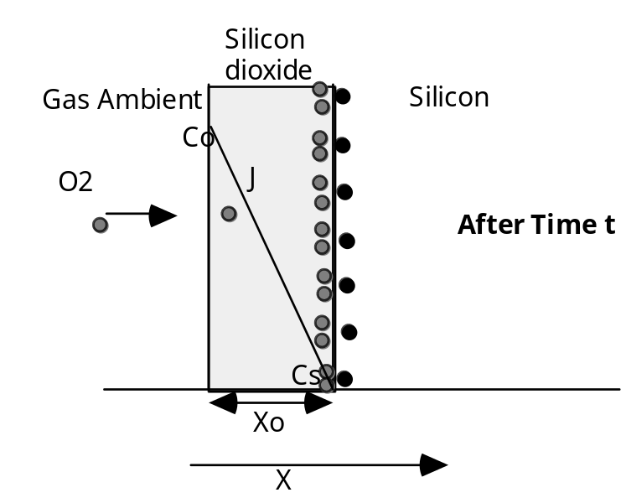

Diagram 1
Reaction controlled
How fast the chemical reaction between the oxidizing species and the silicon can take place
Growth is linear

Diagram 2
Oxide on the surface
Oxidizing species must diffuse through the oxide
As the oxide gets thicker this takes longer
Growth rate becomes dominated by the diffusion time
Growth rate parabolic

Dopant Segregation
Redistribution of Impurities During Thermal Oxidation

Because most impurities diffuse much slower in silicon dioxide than in silicon we expect that an oxide grown on the surface will effectively seal the impurities in the silicon.

The situation is much more complex!! With any two phases in contact, any impurity will be redistributed between the two phases, until equilibrium is reached. In equilibrium the ratio of the concentrations will be constant.

The ratio of the equilibrium concentrations in the silicon and silicon dioxide is denoted by the term segregation coefficient and is defined by :-

Equilibrium conc. of impurity in silicon
M= ---------------------------------------------------------------
Equilibrium conc. of impurity in silicon dioxide

When oxide takes up the impurity M<1
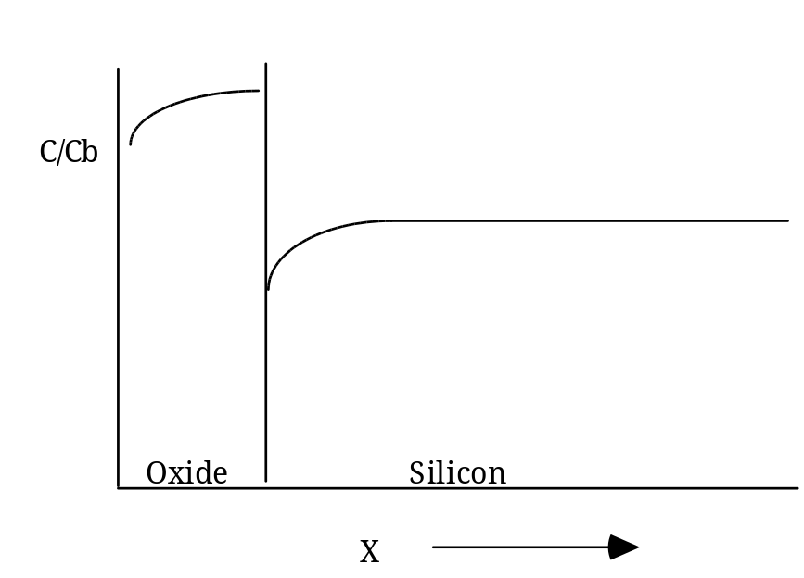

For M>1
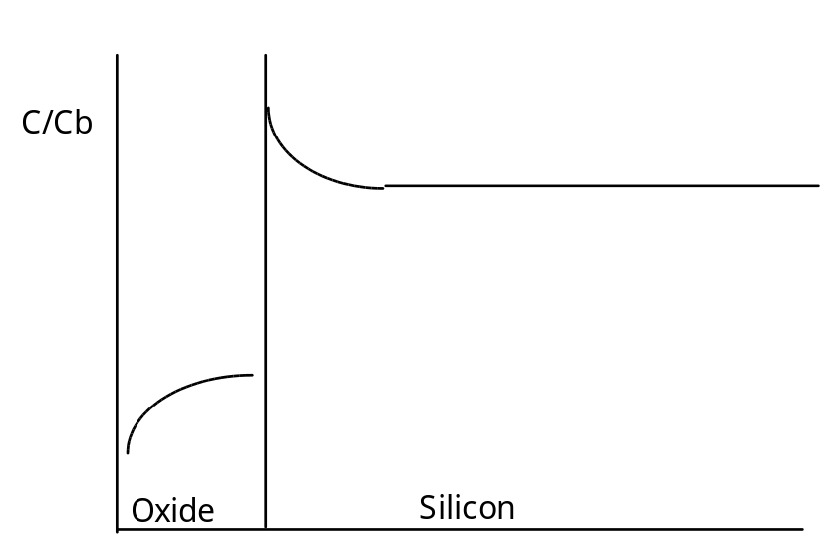

One interesting feature is that this redistribution is independent of oxidation time.

Boron Segregation Coefficient 0.3

Phosphorous Segregation Coefficient 10.0

Common Terms (colloquial)
Boron “suck-out”
Phosphorus “Pile-up” or “Snowplough Effect”
Sample Problems

Oxidation Sample Problem

Q. A silicon <111> substrate is oxidised for 1 hour at 1000°C in steam on removal from the furnace windows are etched in the silicon dioxide down to bare silicon. If the wafer is re-oxidised for 2 hours at 1100°C in dry oxygen calculate the thickness in:

i) The areas which had been etched clear before the second oxidation?

ii) The unetched areas?

Answer
i) To calculate the thickness in the areas which were etched clear before the second oxidation simply read the value from the curve supplied.

On the x axis go to the 120 minute point go up to the intersection with the 1100°C line and read off the thickness.

Ans. 0.18μm

ii) The thickness in the un-etched areas.

This is not a matter of simply adding the thickness already on the wafer to what is grown on bare silicon during the second oxidation.

The thickness of oxide on the wafer from the first oxidation must be converted to the time it would have taken to grow this thickness at the new temperature (1100°C).

The thickness already on the wafer from the first oxidation is 0.42μm. This can be read from the curve for oxidation in steam.

This would have taken 500 minutes to grow at 1100°C. This can be estimated from the Dry Oxygen Curve. Read from the 0.42μm point across to the line representing the 1100°C growth temperature and drop down to the x axis to estimate the time.

This oxide then spends an additional 120 minutes in dry oxygen at 1100°C.

An equivalent of 620 minutes at 1100°C

Look up the total thickness from the second curve for an oxidation time of 620 minutes. Ans. = 0.46μm

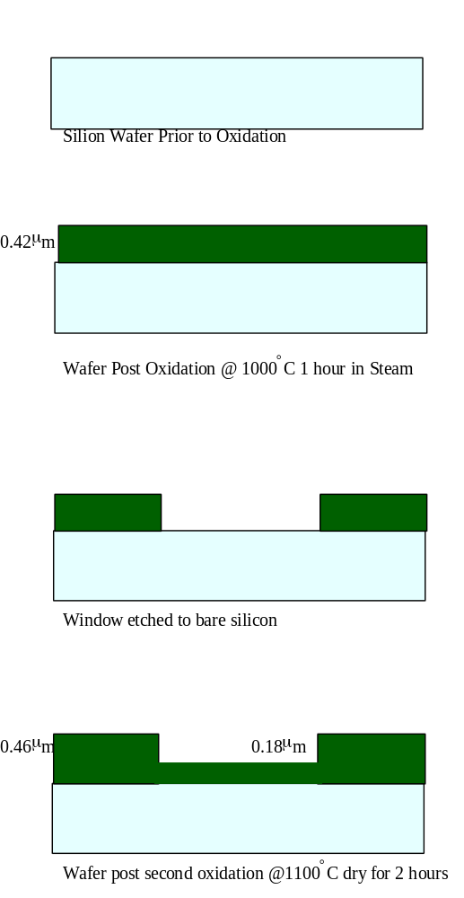

10

1.0

0.1

0.01

11010²10³10⁴
60min
0.42μm
1200°C
1100°C
1000°C
(111) Silicon
(100) Silicon
Oxide Growth In Pyrogenic Steam

10

1.0

0.1

0.01

60min
0.18μm
0.42μm
500min
500min + 120min =620
Oxide Growth In Dry Oxygen
(111) Silicon
(100) Silicon

10 10² 10³ 10⁴

Main Equations Covering Photolithography

Equation Governing the Minimum Resolution of a Contact/Proximity Alignment System :

The minimum resolution of such a system is

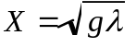

Where x is the minimum printable linewidth and g the gap between wafer and mask and  the wavelength of light being used.

Equation Governing the Minimum Resolution of a Projection Alignment System :

Minimum resolution is roughly 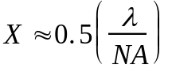

Equation Governing the Depth of Field of a Projection Alignment System :

The depth of focus is 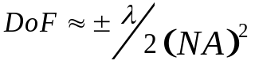

NA is the numerical aperture of the lens

Minimum Resolution of an E-Beam Exposure System:
The effective wavelength of an electron beam from de Broglie's equation is 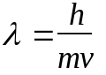

where h is Plancks constant, m the mass and v the velocity at 10k eV is 0.012nM. The beams can be focused and using the information from the CAD system the patterns can be written directly onto the wafers.

Q. If in a fabrication photolithography room the exposure is changed from one in which the wavelength of radiation used to expose the resist is 400nm to a system in which the wavelength used is 325nm and the numerical aperture changes from 0.48 to 0.6 how will these changes affect the minimum resolution possible and what problems will be caused.

Ans. The minimum resolution is given by the expression

The original minimum resolution is

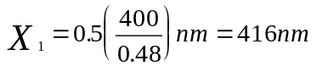
The new minimum resolution will be
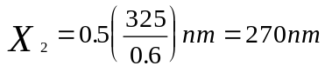

It is more normal to speak of resolution in microns, so the minimum capability of the photolithography reduces from 0.41μm to 0.27μm

But the changes in equipment will also affect the Depth of Focus or the Depth of Field which is given by the expression:

Under the old system this was

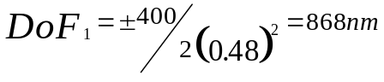

Under the new system
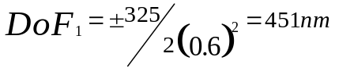

So under the old system there was a focus range of 1.7μm and under the new system this has reduced to 0.9μm

All lines measured from 1.0µm
line on the reticle
E=ENERGY TO PRINT 1.0µm
E1=ENERGY TO PRINT 1.1µm
E2=ENERGY TO PRINT 0.9µm
Exposure =(E2-E1)/E
Latitude
=(190-105)/135
=60%

1.2

1.1

1.0

0.9

0.8
CD µm
100 120 140 180 200

Exposure Energy mj
E
E1
E2

Etching

Select
I
vi
ty
Sputter Etch & Ion Beam Milling
Physical

Processes
Pressure
Anisot
ropy
Energy
High Density Plasma Etch

Reactive ion Etch

Plasma Etch
Chemical

Processes
Chemical Etch

Wet etching is cheap has very good selectivity but is very isotropic (which means it etches in all directions at the same rate). This makes dimension control very difficult.

In small geometry processes the etch of choice is a dry etch system. There are variations in the types of dry etch which can be used. All the dry etches tend to be given the generic name “Plasma Etch” because the basic technique is to strike a plasma discharge in a gas and use the active ions and radicals as the etchants on the surface of the wafer.

The main system used is a parallel plate vacuum system with the wafer sitting on the lower electrode and an RF power supply between the plates, typical frequency 13.56MHz.

Electrode

RF
Wafer

Plasma

Electrode

This is not a full diagram

Plasma Etch
Wafer on the grounded electrode
Pressure 100mTorr – 1 Torr
DC Voltage Drop ≈ 10 100V
Uses chemically reactive gases

Reactive Ion Etch (RIE)
Wafer on the powered electrode
Pressure 10mTorr – 100 mTorr
DC Voltage Drop ≈ 100 700V
Uses chemically reactive gases

High Density Plasma (HDP) several systems ICP – Inductively Coupled Plasma, Helicon Wave etc.
Wafer on the powered electrode
Pressure lower than RIE
Plasma generated inductively by coil or magnetic field remote from wafers.
Plasma density orders of magnitude higher than RIE (10¹⁰ – 10¹² ions/cm³)
Uses chemically reactive gases.
Less plasma damage because of remote plasma for higher etch rates.

Ion Milling
Wafer on the powered electrode very high ratio of grounded area to powered electrode
Pressure , 10mTorr
DC Voltage Drop ≈ order of kV
Uses inert gases (Ar etc)

Linear Etch Model

Two factors in determining the etch rate the amount of physical etch and the amount of chemical etch.
The chemical etch will cause a degree of isotropy as is non-directional (all directions) physical etch is directional.

Chemical Element Physical element

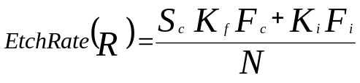

Under the masking material only the chemical element is present as the mask material prevents ion bombardment.
Using a linear etch model for a silicon etch with Photoresist as a masking material, where;
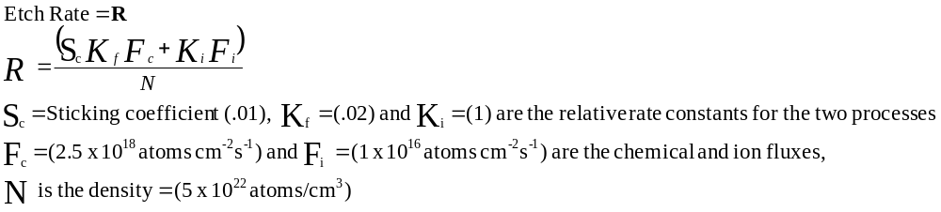How deep is the silicon etched in the vertical direction well away from the mask edge, and in a lateral direction under the mask edge, if the etch time is 10 minutes?

Well away from the mask edge there is both chemical and physical etchinig, close under the mask edge there is no ion bombardment or physical etch so there is only the chemical etch.
Vertical Etch well away from mask edge
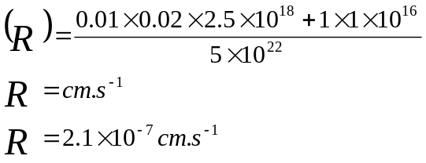
For a 10min etch time (600 sec)
Etch depth is 1.26 x 10⁻⁴ cm or 1.26μm
At the mask edge there is under the mask there is no physical etch component

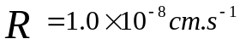
For a 10min etch time (600 sec)
Etch depth is 6.0 x 10⁻⁶ cm or 0.06μm
Second Etch Example

Example A 0.5-J.Lm layer of silicon dioxide on a Si substrate needs to be etched down to the Si. Assume that the nominal oxide etch rate is rox (in J.Lm min -1). There is a
= 5% variation in the oxide thickness and a:: 5% variation in the oxide etch rate. (a) How much overetch is required (in % time) in order to ensure that all the oxide is etched? (b) What selectivity of the oxide etch rate to the Si etch rate is required so that a maximum of 5.0 nm of Si is etched~ (Assume the overetch calculated in part (a) is done.)
Answe~ (a) The nominal etch time = x/rox = 0.5/rox (x = thickness in J.Lm.) The overetch is done to make sure all the oxide is etched for the worst case condition: that means for the thickest oxide and the slowest etch rate. The thickest oxide
-------------------------------------------
- - -
0.5 * 1.05 = 0.525 J.Lm. The slowest etch rate = rox * 0.95 J.Lm min -l. The time to etch the worst case = x/r = 0.525/(rox * 0.95) = 0.553/rox min. The amount of overetch. in % time. is just the worst case etch time divided by the nominal etch time = (0.553/rox)/(0.5/rox) = 1.106 or 10.6% ov~retch.
(b) The maximum amount of Si that will be etched will occur under the thinnest oxide being etched at the fastest etch rate. The thinnest oxide is 0.95 * 0.5 J.Lm = 0.475 J.Lm. The fastest etch rate is rox * 1.05 J.Lm min -I. The time to etch through that oxide is x/r = 0.475/(rox * 1.05) = 0.4523/rox min. The time that the Si is exposed to the etch is equal to the total etch time (0.553/rox. as calculated in part (a)) minus the time it took to etch the thinnest o'xide, etching at the fastest rate. or

Example A 0.5-J.Lm layer of silicon dioxide on a Si substrate needs to be etched down to the Si. Assume that the nominal oxide etch rate is rox (in J.Lm min -1). There is a
= 5% variation in the oxide thickness and a:: 5% variation in the oxide etch rate. (a) How much overetch is required (in % time) in order to ensure that all the oxide is etched? (b) What selectivity of the oxide etch rate to the Si etch rate is required so that a maximum of 5.0 nm of Si is etched~ (Assume the overetch calculated in part (a) is done.)
Answe~ (a) The nominal etch time = x/rox = 0.5/rox (x = thickness in J.Lm.) The overetch is done to make sure all the oxide is etched for the worst case condition: that means for the thickest oxide and the slowest etch rate. The thickest oxide
(0.553/roJ - (0.4523/'-oJ = 0.1003/,-ox min
We want to etch 0.005 J.Lm or less of the Si. so
'-Si =x/time =0.005/(0.i003/'-oxh1m~in-1
= 0.050 " ,- ox flm min - j
The selectivitv of oxide etch rate to Si etch rate is therefore:
'-ojrSi = '-0.1(0.050 " rox) '-ox/rSi = 20:1
Diffusion Sample Problem

Conditions :

Temperature 950°C Time 30 minutes

Substrate doping 5 Ωcm 1x 1015 atom/cm3

Solid Solubility of Boron in Si at 950°C
1.5 x 10²⁰ atoms/cm³
√D = 0.045µm/√hr
D = 5.6 x 10-15 cm2/sec

Predeposition or constant source
Question? find the junction depth (x_{j)} and The total dopant quantity (Q)

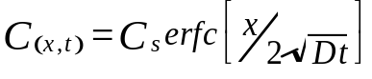

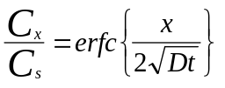

1x 1015 atom/cm3

Cs = Solid Solubility
1.5 x 1020 atom/cm3

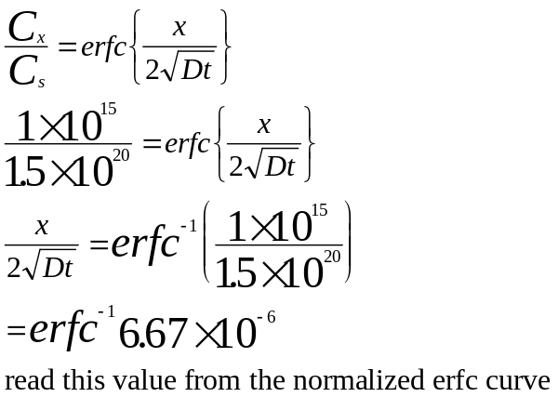

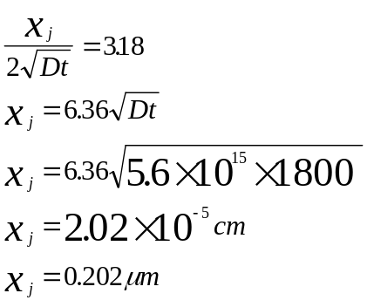

Find The Total Dopant Quantity (Q)

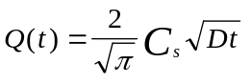

Cs=1.5 x 1020 atom/cm3

Dt=5.6 x 1015 x 30 x 60

Q(t) = 5.38 x 1014 atoms/cm2

Note the units here, doping concentration is in atoms/cm³, dopant quantity or dose is in atoms/cm²

Second Phase :

Constant Total Dopant - Drive In

Dopant quantity (S) is the Q from previous phase

Conditions

Temperature =1100°C

Time =60 minutes

√D =0.27µm/√hr

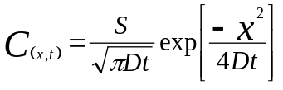

Find the junction depth (x_{j}) and the surface concentration (Cs)

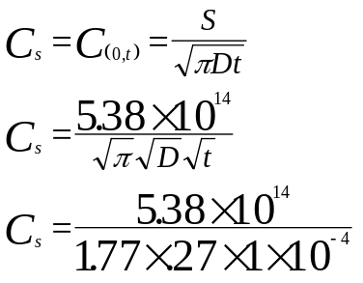

Cs = 1.12 x 1019 atoms/cm3 Surface Conc.

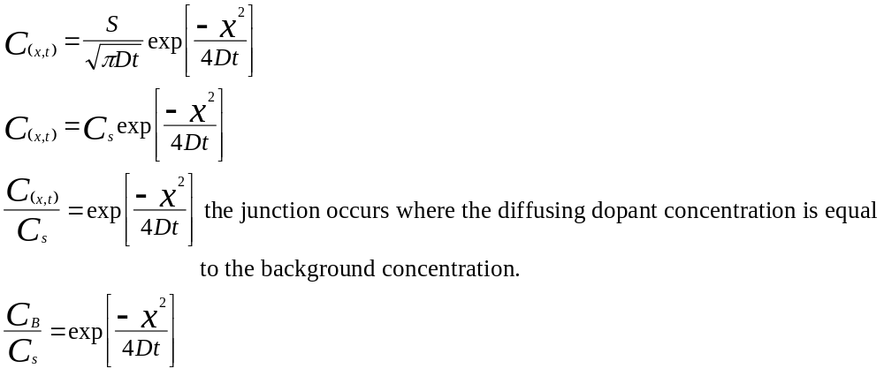
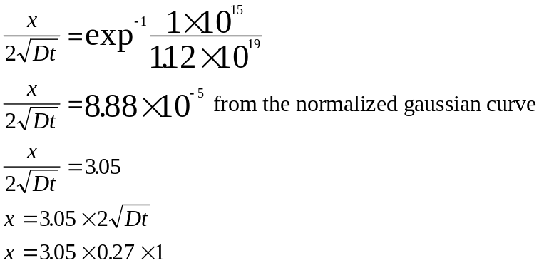
x=1.65µm Junction Depth
1

10⁻¹

10⁻²

10⁻³

10⁻⁴

10⁻⁵

10⁻⁶

10⁻⁷

Normalised Complementary Error Function

Cx/Cs

6.67 X 10⁻⁶

3.18

0 1 2 3 4 5
X/2√Dt

1

10⁻¹

10⁻²

10⁻³

10⁻⁴

10⁻⁵

10⁻⁶

10⁻⁷

Normalized Gaussian Distribution

Gaussian
e^{-α**2}

α= X/2√Dt

Cx/Cs
8.8 X 10⁻⁵

3.05

0 1 2 3 4 5
X/2√Dt
Ion Implantation
Mathematical Model for Ions Implanted into Single Crystal Silicon:

Ions with a particular energy collide with the atoms of the crystal lattice. These collisions and interactions mean that the incident ions do not have a straight path to their ultimate resting place in the target material.

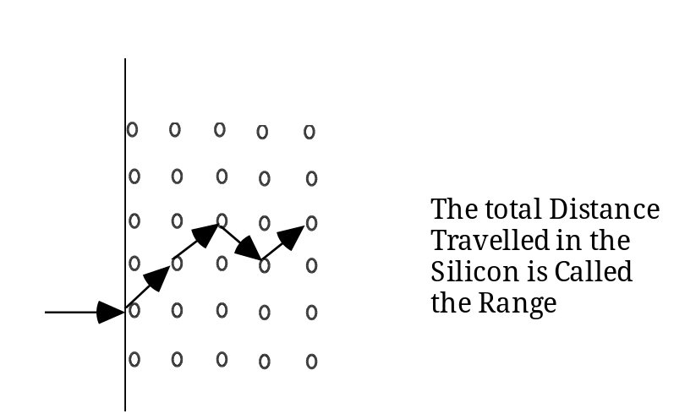

The total distance the ion travels in the target material is the range generally called R.

The projection of the distance along the x-axis is the projected range, Rp, and is the effective distance into the material.

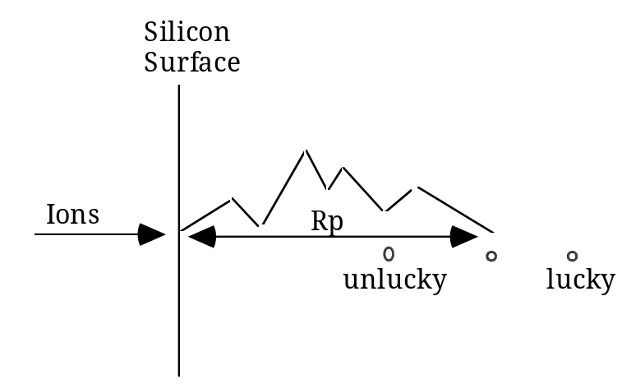

Some ions will be 'lucky' and travel further than the mean distance. Some will be unlucky and travel less far. The distribution is characterised by the std. deviation. ΔRp sometimes called the straggle. The ion distribution is Gaussian with mean Rp and std. deviation ΔRp.

The expression which describes this distribution is :
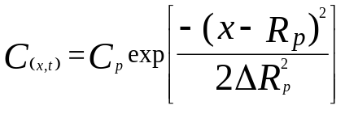
or

N(x) = Np exp[-(x-Rp)2/2ΔRp2]

The area under the gaussian curve is the implanted dose and is equal to
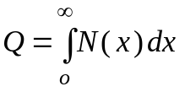

for an implant completely contained within the silicon the dose is equal to

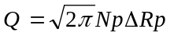
(This equation not given for exams)
Note how similar the concentration equation is to the diffusion equation -

4Dt is represented by 2ΔRp2

Similar but the distribution is shifted along the x axis by Rp.

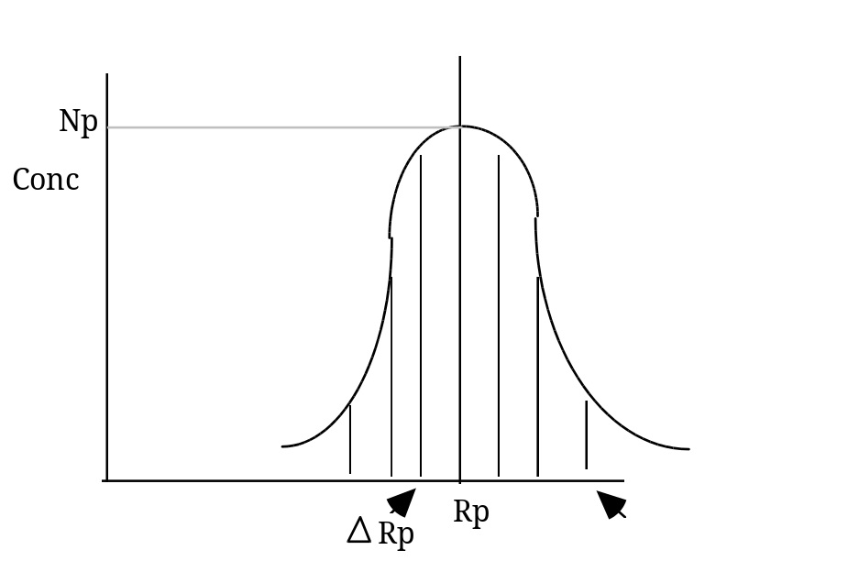

The range into the silicon is dependant on the energy of the implant.
Junction Formation :

Remember the concentration Vs distance in to the silicon curve for diffusion :

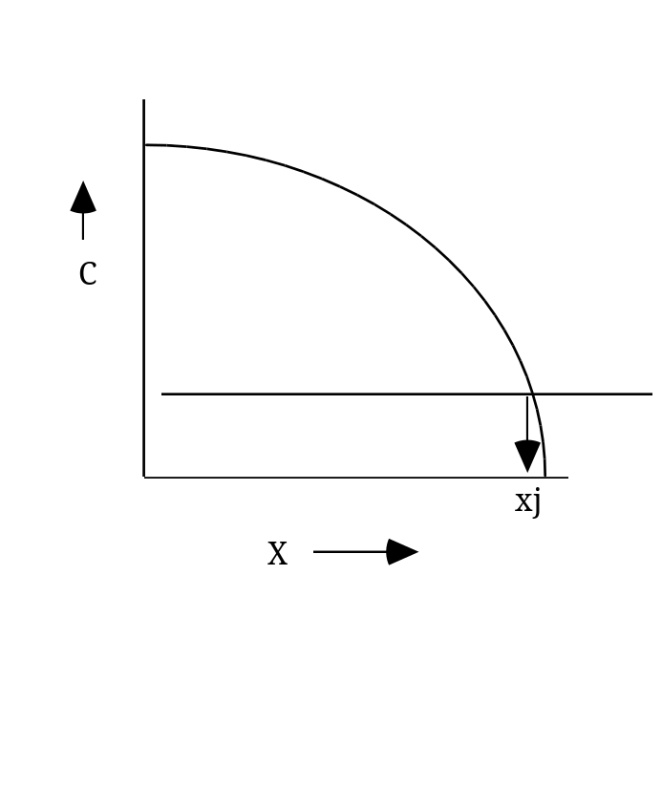

If an implant is implanted with enough energy to be completely contained within the silicon it is possible to have two junctions.
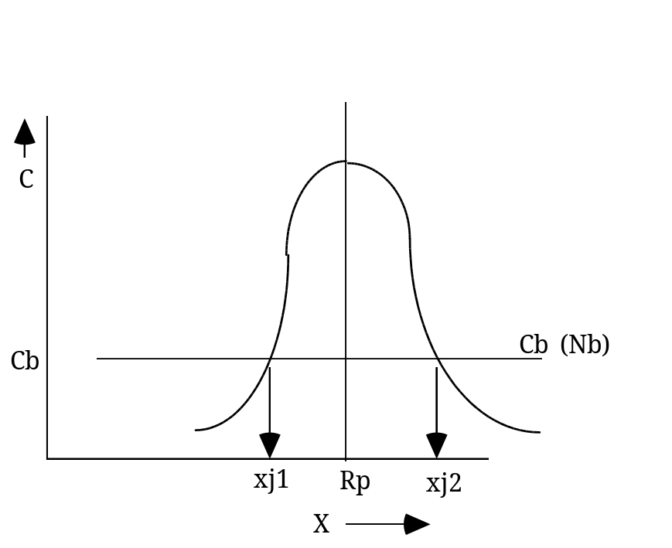

The concentration equation N(x) = Np exp[-(x-Rp)2/2ΔRp2]

at the junction Nx = Nb the bulk or substrate concentration

Nb = Np exp[-(x-Rp)2/2ΔRp2]

xj = Rp + ΔRp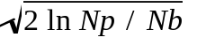

i.e. Boron implanted to a depth of 0.3µm with a peak concentration of
Np = 1 x 1018/cm3 into a substrate of doping 3 x 1016/cm3.

Implant energy 100kv straggle 0.07µm
xj = Rp + ΔRp
xj = 0.3 + 2.65 (0.7)
xj1= 0.3 - .186 xj2= 0.3 + .186

xj1= 0.114 xj2= 0.486

To use this equation for an implant where the peak is put at the interface between the oxide and the silicon in the final calculation the Rp value is set to 0 to calculate the junction depth..

Selective Implantation or Masking :

Implant into silicon is generally done through an oxide this, because the oxide is amorphous can help prevent channelling. Also it can prevent contamination by metal ions in the silicon as the implant oxide is often etched off afterwards. It is generally desirable to implant only certain areas. The areas where the implant should not go are often masked off by thicker oxides.

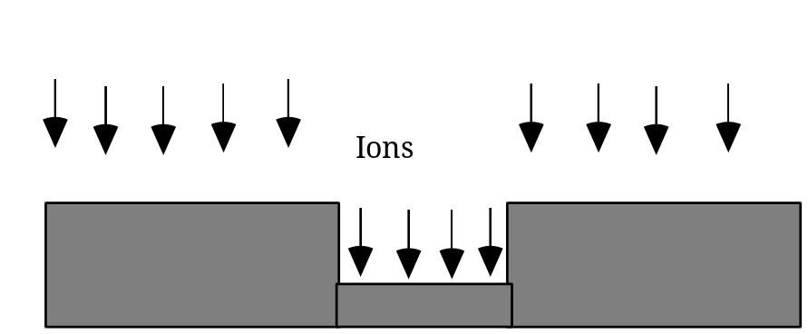
To prevent significantly altering the doping in the silicon we require that the implanted concentration be less than 1/10 the background concentration at the thick Si/SiO2 interface.
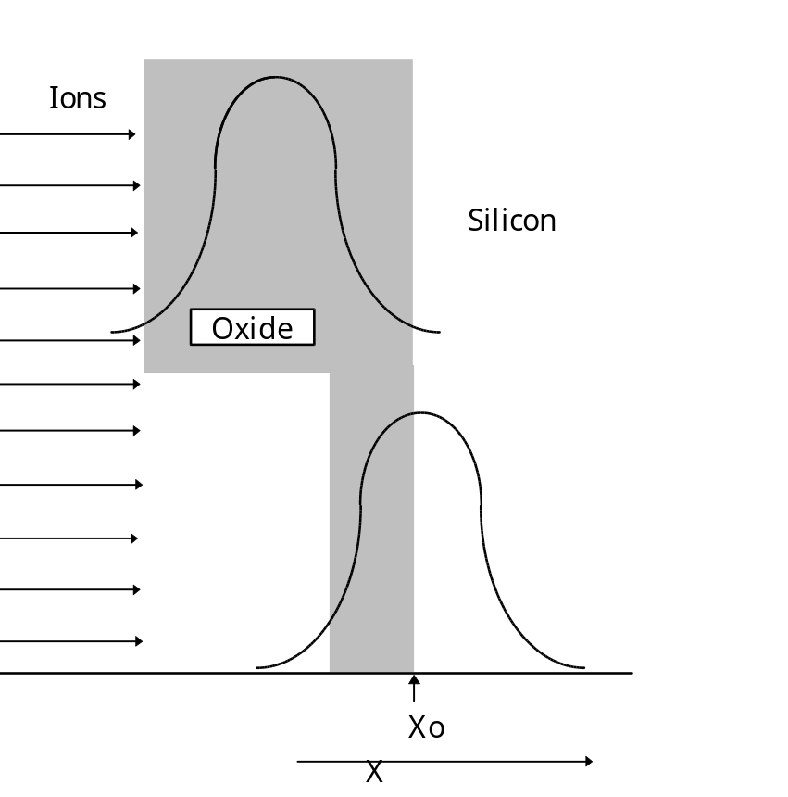

Solving the concentration equation
N(x) = Np exp[-(x-Rp)2/2ΔRp2]

for Xo yields a max SiO2 thickness only the positive root valid
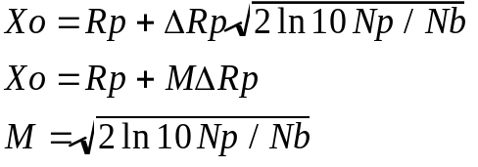
for various ratios of Np/Nb 101 M = 3.0
103 M = 4.3
105 M = 5.3
106 M = 5.7

The 10 in the equation comes from the fact that it is assumed that the oxide is thick enough to block the implant if any dopant getting through is less than 1/10 of the background concentration.

Beam Current to Dose Conversion

Beam Current typically measured in μA
Dose is measured in Ions/cm²

Consider a beam current of 1μA

1μA= 1μCoulomb/sec
Magnitude of electronic charge = 1.602 X 10⁻¹⁹ coulomb

1 coulomb = 1/1.602 x 10⁻¹⁹ Ions

1 microcoulomb = 1x 10⁻⁶/1.602 X 10⁻¹⁹
6.3 x 10¹² Ions

1μA = 1μC/sec
6.3 x 10¹² Ions/sec

Typical scanned area for a 100mm wafer is 104cm²

Dose in the scanned area = 6.3 x 10¹² Ions/sec/104cm²
= 0.6 x 10¹¹ions/sec.cm²
A 10 second implant at this current (1μA) would then give:
6 x 10¹¹ Ions/cm²
This can be reduced to the equation

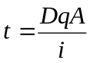

Where t is the implant time, D is the required dose, A is the area of implant, i is the full scale current and q is the electronic charge.

Q. If one wafer is predeposited with boron at 950°C for 30 minutes and a second wafer has boron implanted at a dose of 5X1014 ions/cm² such that the peak of the implant is at the oxide/silicon interface, and both wafers are driven-in at 1100°C for 60 minutes, compare the surface concentration of boron in both wafers at the end of the drive-in?
Solid Solubility of boron in silicon @ 950°C is: 1.5X10²⁰atoms/cm³
Diffusion coefficient of boron @ 950°C is: 5.6X10⁻¹⁵ cm²/sec
Diffusion coefficient of boron @ 1100°C is: 2.0X10⁻¹³ cm²/sec

Given:

for predeposition

for drive-in

Ans.
Surface concentration after the drive-in can be determined by solving for C_{(x,t)} at x=0

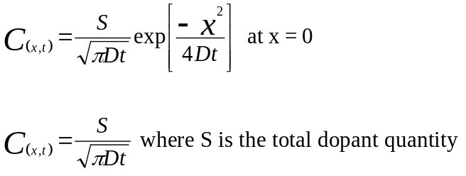

There will be a different S from the predeposition and the implant case

Predeposition: The total dopant quantity is given as Q

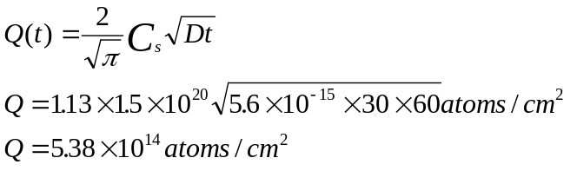

Implantation: The total dopant quantity is given by the dose of the implant, but in the case in question the implant peak was at the interface between the oxide and the silicon so approximately half of the implanted ions are lost into the oxide.

So the total dose for the implant is 2.5X10¹⁴atoms/cm³

Solve 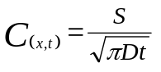

for the predeposition case

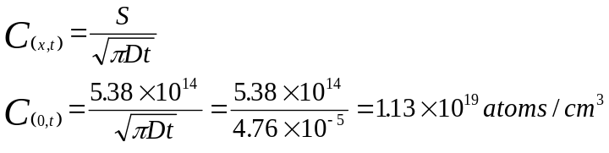

For the implantation case

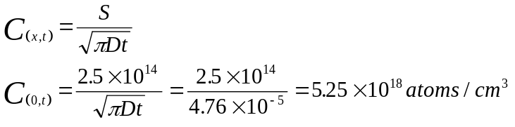

Metallization

Techniques for metallization for semiconductors
PVD
Evaporation – poor stepcoverage, difficult to deposit alloys

Sputtering – Industry standard up to 180nm process node, alloys are easy, step coverage is better than evaporation, can still be difficult into high aspect ratio contacts. Sputter to cover entire wafer and etch off unwanted metal.

Damascene Process – In vogue post 180nm node, involves etching trenches in the oxide dielectric, plating metal (copper) to fill trench and above, CMP to planarize and remove excess metal (no etch).

Sheet Resistance:

Consider the resistance of a block of uniformly doped material or metal.

R=ρL/A

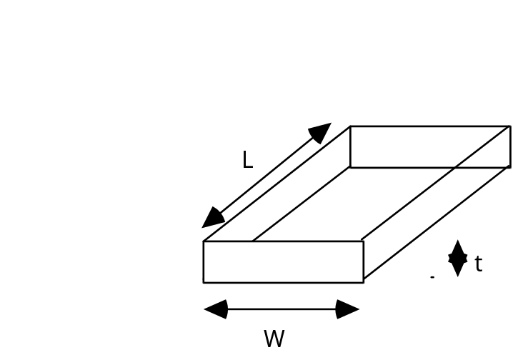

R= ρ L/t . W

R= ρ/t . L/W

ρ/t is called the sheet resistance

Rs= ρ /t

ρ is the bulk resistivity of the material in ohm.cm
Given the sheet resistance of a resistor, a designer need only know the L and W (i.e. the number of squares ) to define its value. Strictly speaking Rs should be defined in ohms as L/W is dimensionless, but to avoid confusion with R, Rs is given as ohms/.
Device Equations

Below is a plot of typical output characteristics of a MOS transistor. It shows the relationship between the source/drain current for increasing drain voltage at various levels of applied gate voltage

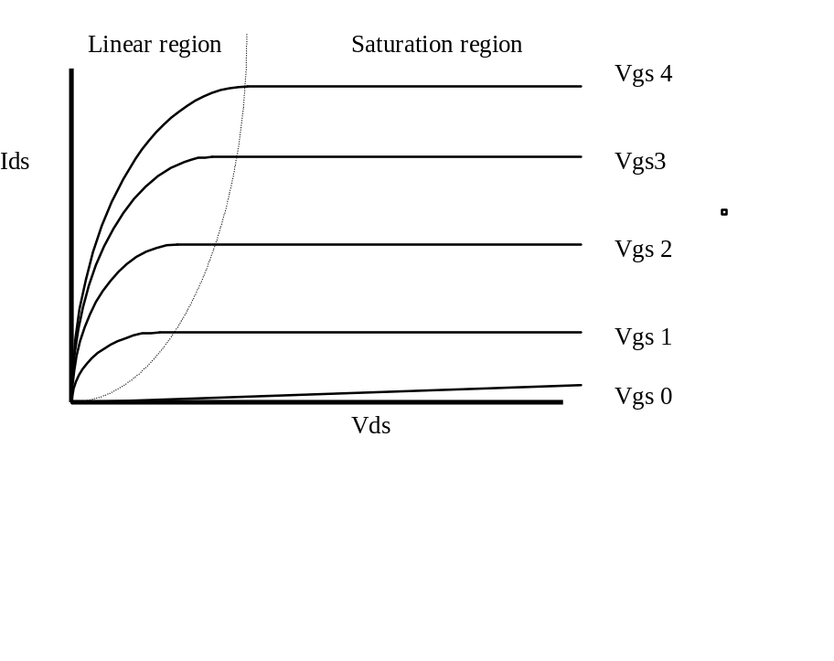

The equation which describes device operation in the linear region is :

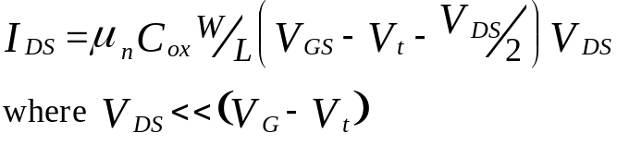

For the linear region
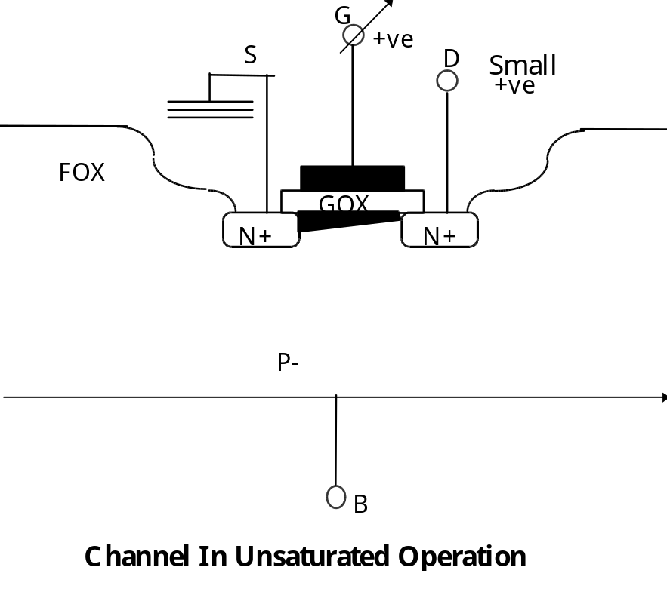

The equation which describes operation of devices in the saturated region is

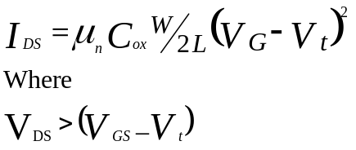

For the saturated region

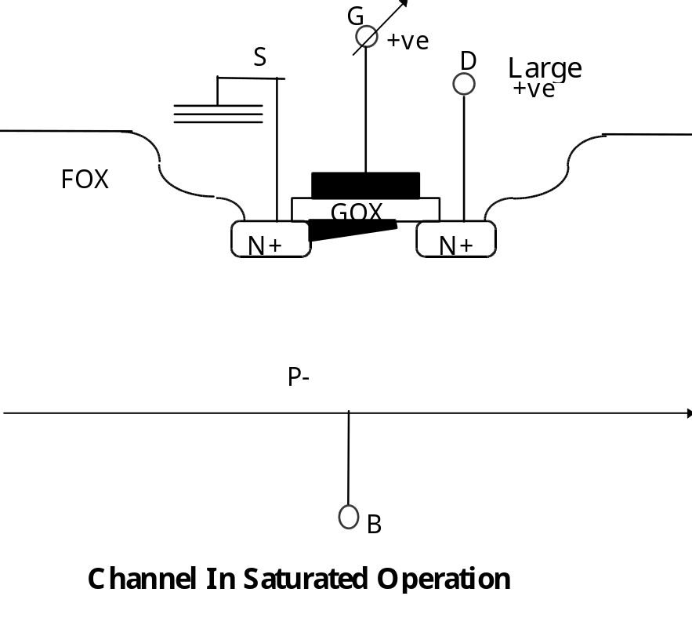

In these equations
μ_{n} = Minority carrier mobility in the substrate
C_{ox} = The oxide capacitance of the gate oxide in the device
W = The device width
L = The device length

SOI DEVICES
Remember MOS devices can also be configured on SOI (Silicon on Insulator) substrates. This is where the silicon on which the devices are formed is a thin layer of silicon on top of an insulator, usually silicon dioxide, in turn supported by a bulk silicon wafer underneath.

Source N+
Drain N+
Gate
Buried Oxide or Back Gate Oxide
Back Gate (Substrate)
Vs
Vg1
Vd
Vg2
t_{ox2}
t_{ox1}
P-Type body
t_{si}
Depending on the thickness of the silicon layer and the biasing voltages the device can operate either as a fully depleted or partially depleted device.

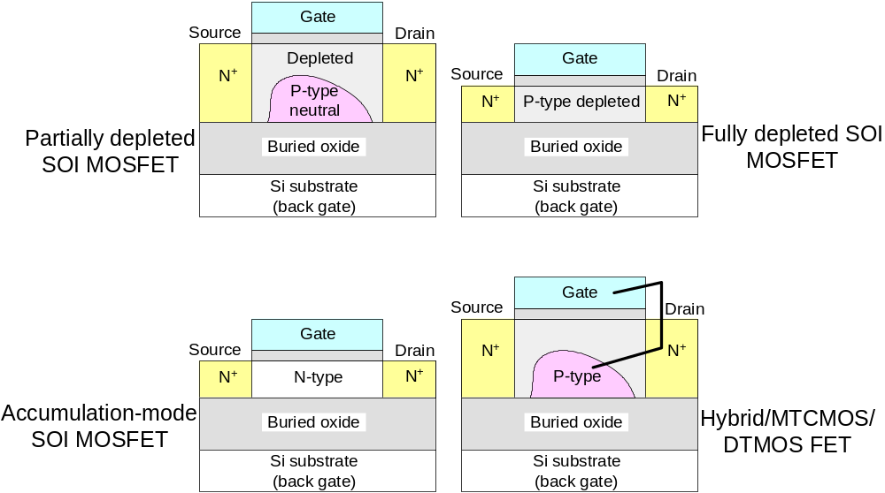
Q. In a process which has an N channel Threshold voltage (Vt) of 1.0V and a maximum power supply voltage of 15V what is the minimum size device (W/L) which can give a maximum saturation current of 15mA if the minimum gate length is 5μm?
Given: C_{ox} = 3.0 x 10⁻⁸ F/cm²
μ_{n} = 600 cm²/V.s

Ans. Because it is the saturation region the relevant equation is
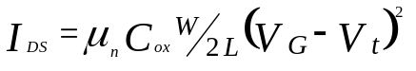
It is a minimum size transistor so L = 5μm

Maximum applied voltage will be the power supply voltage: V_{G} = 15V

V_{t} = 1.0V as above

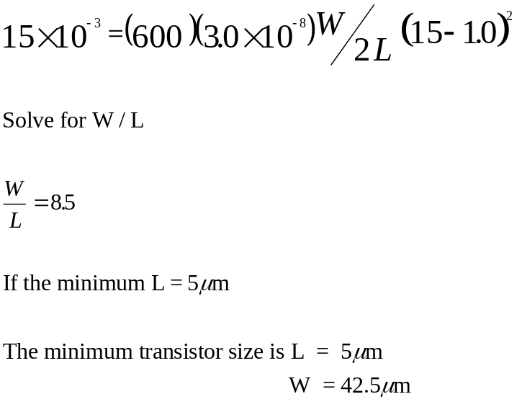

Remember the capacitance can be calculated from the equation
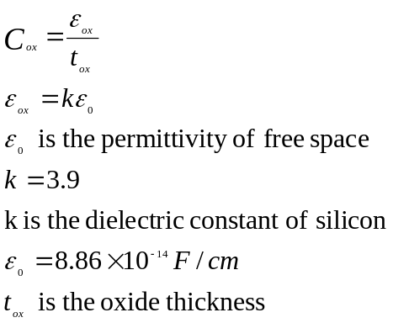

Threshold Voltage Equations

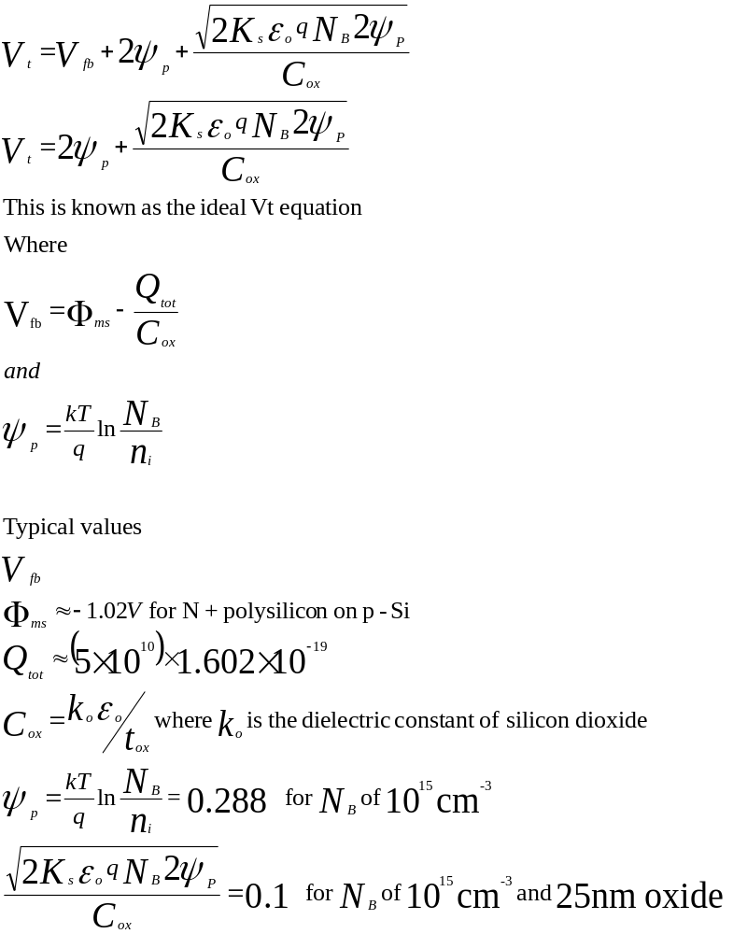
FROM ABOVE
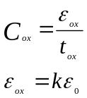

Remember: The Vt equations for devices are also valid for the parasitic transistors that can be formed in the field regions of ICs. The only differences will be reflected In the fact that the Cox will be lower to reflect the thicker oxides In the field regions where the gate dielectric will consist of the field oxide and in the case of the metal gate field transistor the field oxide and the BPSG layer (the dielectric between the poly layer and the first metal layer. The differences in the doping levels between the field region and the channel region is incorporated in the 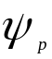 term.

If the gate dielectric increases Cox reduces and the Vt increases
If the dielectric constant increases change from a pure oxide to a high k dielectric and thickness remains the same Cox increases and the Vt will reduce.

If the substrate concentration changes (say increases) the Nb term increases in the Vt equation twice in Ψp, more voltage is required to invert the surface, the Vt will increase.

If oxide charge changes (say increases), for an NMOS device where a positive voltage is applied to the gate electrode to turn on the device. The oxide charge is usually positive so less voltage would now be needed to invert the channel surface, so the Vt would reduce.

Substrate bias, it is assumed that bias for MOS devices is reverse bias, reverse biasing the substrate has the effect of increasing the Vt. The MOS device is turned on by inverting the channel region between the source and the drain. A reverse bias has a depletion region associated with it proportional to the size of the bias. This reverse bias on the substrate has the effect of squeezing or narrowing the conduction channel, more voltage needs to be applied to the gate to overcome the reverse bias, thus increasing the Vt.

The body effect is a measure of the amount by which the threshold voltage shifts if an additional reverse bias (V_{BS}) is applied to the substrate. This is described by the equation below.
